**Aim:** Create a simple cloud software application for Payroll Processing System using any Cloud Service Provider to demonstrate SaaS include the necessary fields such as Name of the employee, experience in present org , over all experience, basic pay, HRA, DA, TA, net pay, gross pay etc.

**Step 1:** Create an application ‘payroll processing system’ and add form ‘initial setup’ and add details.

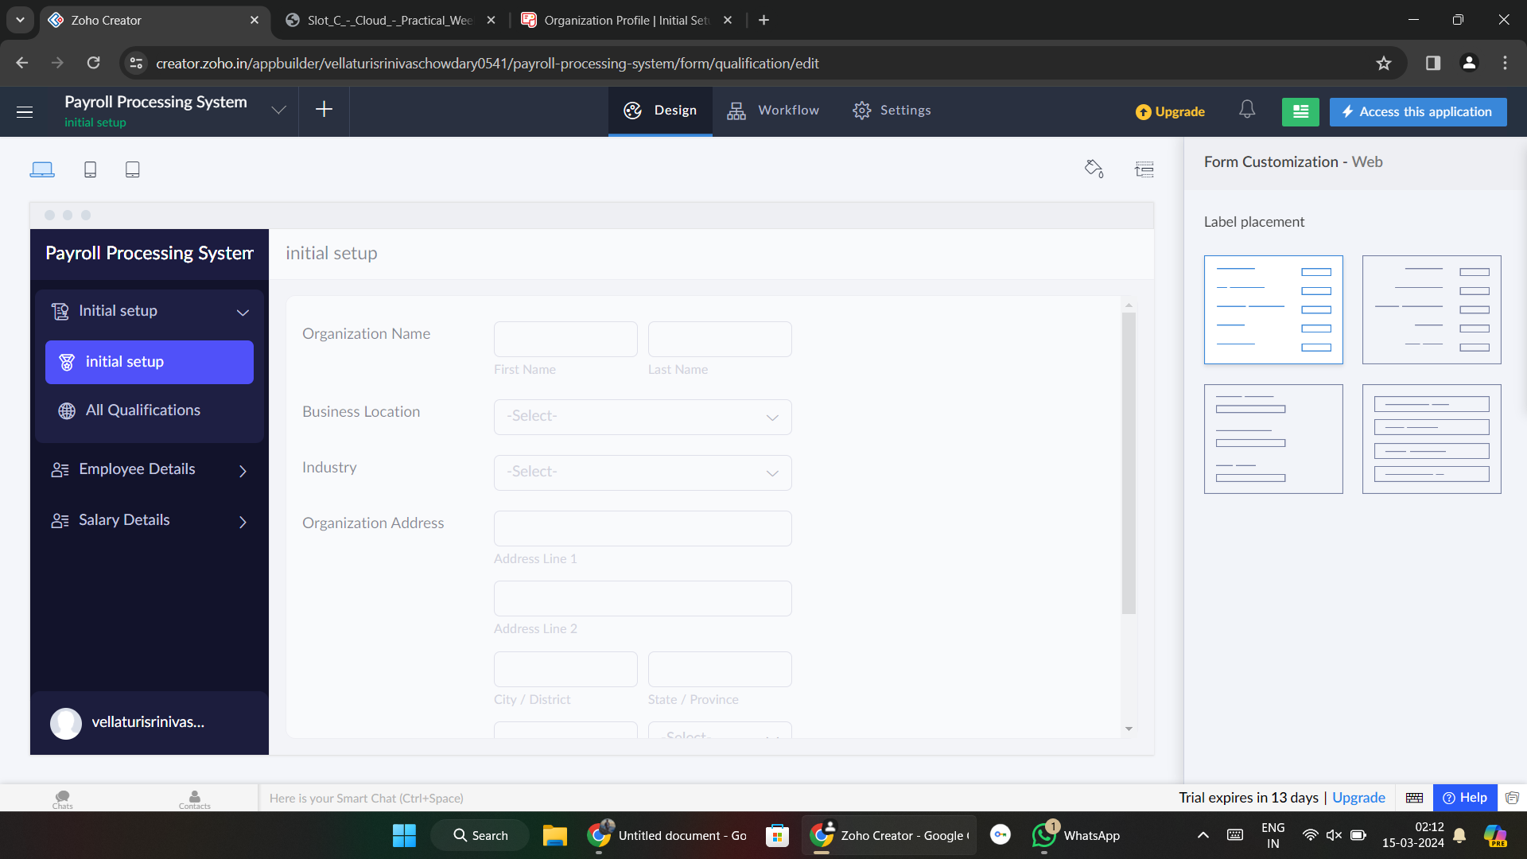

**Step 2:** Add form ‘employee details’ and add details.

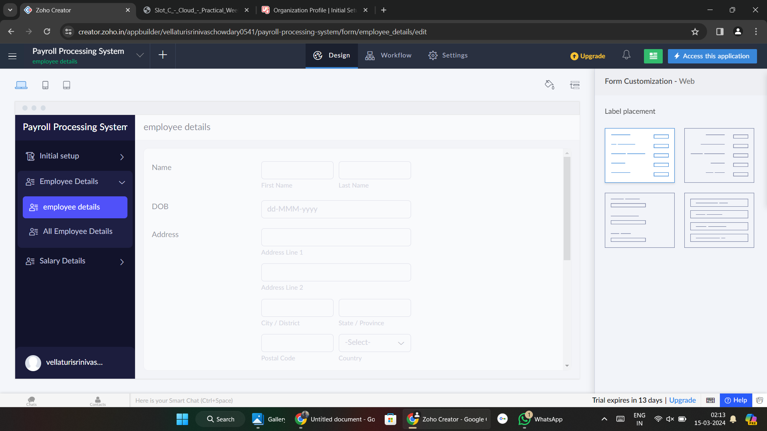

**Step 3:** Add form ‘Salary Details’ and add details.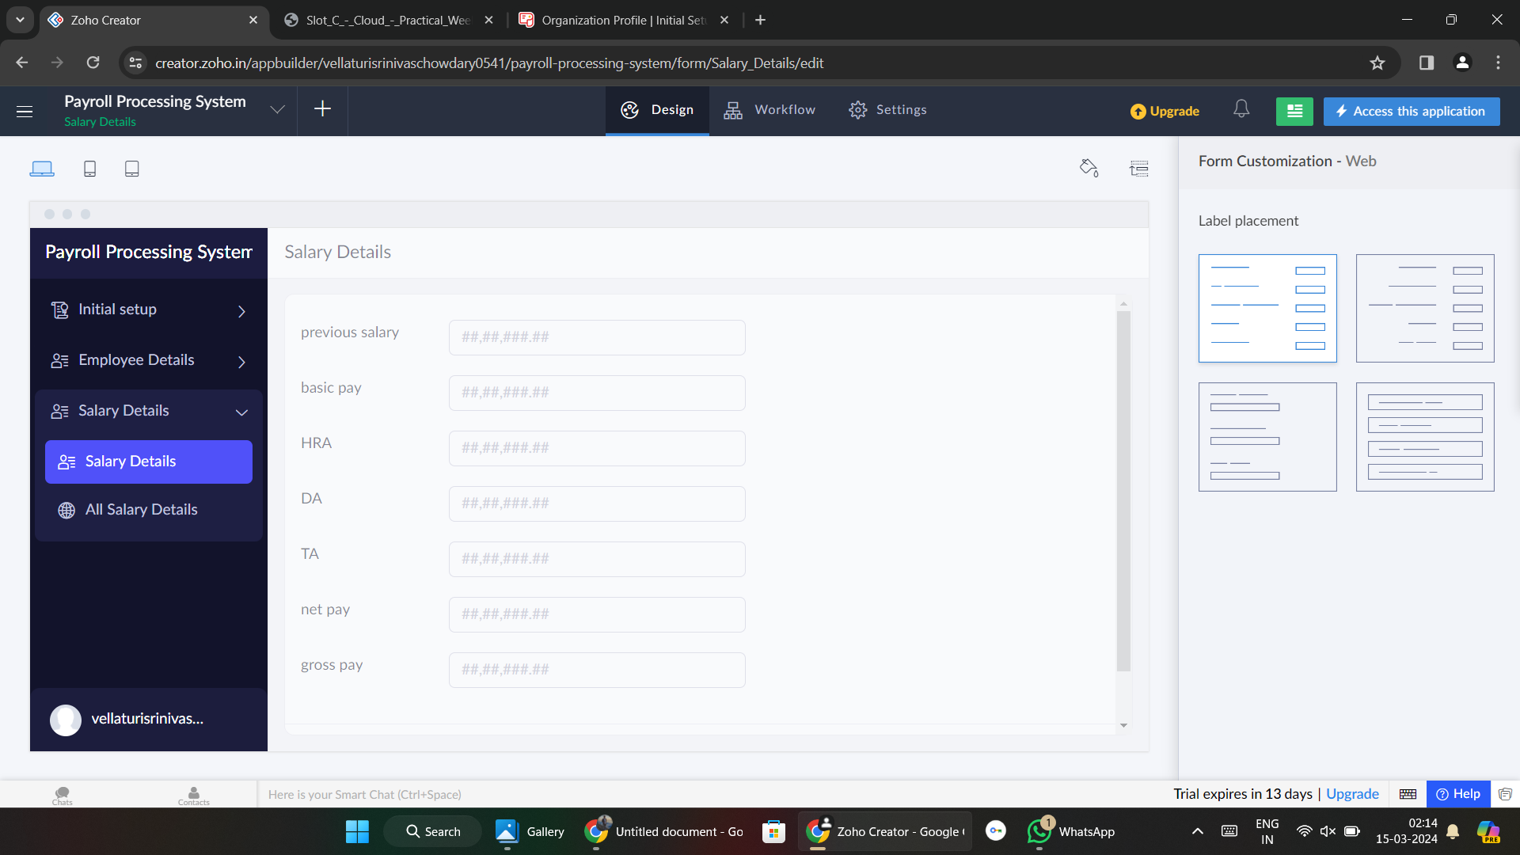

**Step 4:** Fill the details.

